Cosmic Breath Inversion Model
A Speculative White Paper PoC on Inverse Collapse Cosmology
Document Type | Speculative cosmology white paper / proof of concept
Core Claim | Observed expansion may be the visible projection of a deeper collapse-like reconciliation process
Interpretive Layers | Metaphor, geometric hypothesis, and information-structure hypothesis
Position | Exploratory framework, not an established physical theory

Abstract
This paper packages a speculative cosmology concept in which the universe may not be simply expanding outward from an origin event, but instead exhibiting the observable face of a deeper collapse-like or reconciliation process. The model starts from a poetic premise — the universe as breath — and separates that metaphor from two more rigorous hypothesis layers: a geometric inversion hypothesis, in which expansion can emerge from coordinate or curvature effects, and an information-structure hypothesis, in which dark components may reflect missing relational structure rather than only unseen material substance. This is presented as a conceptual proof of concept intended to clarify the model's internal logic, not as a validated replacement for standard cosmology.
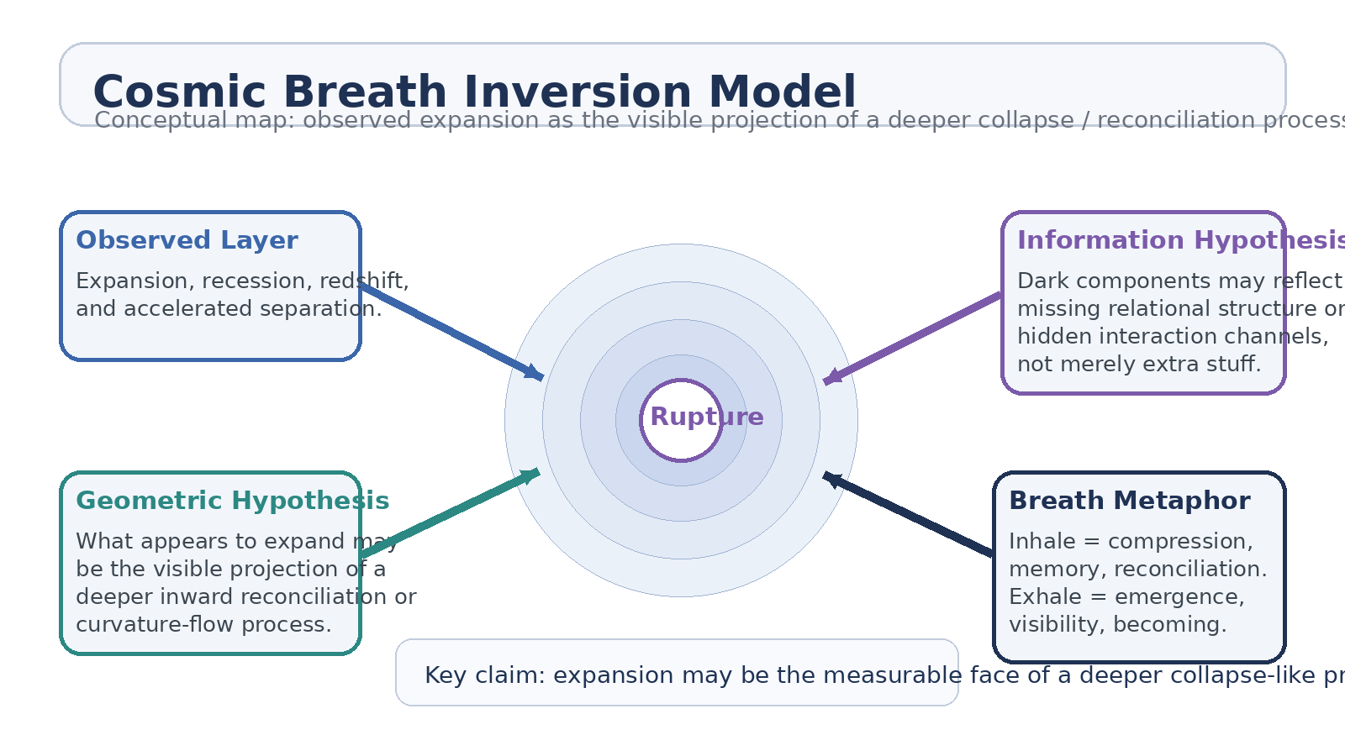
Figure 1. Concept map for the Cosmic Breath Inversion Model.
1. Starting Intuition
The initiating intuition is simple: what if the Big Bang is better interpreted not as a one-time explosion outward, but as a rupture, puncture, or loss event in a deeper structure of reality? Under that framing, the apparent expansion of the universe may be a visible consequence of a more global inward reconciliation, relaxation, or collapse process. The idea is not that galaxies are secretly moving toward one ordinary point in space, but that the geometry we observe may encode the aftermath of a boundary failure in a higher-order system.
2. Separation of Layers
2.1 Metaphor Layer
The universe is breath. Inhale corresponds to compression, memory, and inward reconciliation. Exhale corresponds to emergence, visibility, and becoming. This layer is intentionally poetic and is useful because it gives the model an intuitive rhythm without pretending that metaphor alone is physics.
2.2 Geometric Hypothesis Layer
Observed expansion may be the measurable projection of a deeper collapse-like process, depending on how spacetime is embedded, curved, or coordinated. In this sense, outward recession on one description may coexist with inward reconciliation on another.
2.3 Information Hypothesis Layer
Dark components may reflect missing relational structure or hidden interaction channels rather than only extra matter or a simple repulsive fluid. This does not eliminate the need for equations; it only redirects the conceptual target from 'missing stuff' toward 'missing structure.'
3. Why the Model Exists
• To provide a cleaner language for the intuition that observed expansion may not exhaust the true global behavior of the cosmos.
• To separate a symbolic cosmology from a more testable geometric or information-theoretic hypothesis.
• To ask whether dark matter and dark energy could partly reflect inaccessible interaction structure rather than only unknown material components.
• To frame a speculative model without pretending it already replaces the successful predictive machinery of standard cosmology.
4. Standard Cosmology: The Baseline It Must Confront
Any alternative cosmology must still account for the observational pillars already explained, at least in broad outline, by the standard model of cosmology. Those include the Hubble-Lemaître relation, the cosmic microwave background, large-scale structure formation, primordial nucleosynthesis, gravitational lensing, and the observed acceleration inferred from distant Type Ia supernovae. The purpose of this section is to keep the paper honest: a new idea is only interesting if it can eventually climb the same mountain.
Observed Fact | Standard Reading | Inversion Question
Galaxy redshift | Space expands and distant galaxies recede. | Could this be the visible face of a deeper geometric relaxation process?
CMB structure | Relic radiation from an early hot dense state. | Could the same pattern emerge from a rupture-and-reconciliation history?
Dark matter effects | Unseen gravitating component shapes halos and lensing. | Could some effects reflect hidden relational structure or inaccessible interaction sectors?
Accelerated expansion | Dark energy or equivalent drives late-time acceleration. | Could apparent acceleration arise from coordinate, embedding, or memory-like structural effects?

5. Core PoC Hypothesis
The proof-of-concept claim is modest but sharp: what we currently describe as cosmic expansion may be reformulated as the observable projection of a deeper collapse-like reconciliation process. In that reformulation, the Big Bang is treated not as a conventional outward blast but as a rupture event whose aftermath produces both visible recession and hidden structural realignment. The farther one looks, the more one measures not merely distance from an origin, but placement within a continuing global relaxation process.
• Big Bang as rupture: the initiating event is interpreted as a puncture or boundary failure rather than a conventional explosion metaphor.
• Expansion as projection: observed recession is real at the measurement layer but may not be the whole story at the global geometric layer.
• Dark structure as missing relation: at least part of the dark sector may represent hidden relational degrees of freedom rather than only hidden substance.
• Cosmic breath as scaffolding: inhale and exhale are retained as explanatory metaphors for compression and emergence, not as literal equations.
6. Dark Matter as Missing Interaction Structure
In ordinary language, the idea was phrased as memory loss between particles. To make that usable as a research-level concept, it must be translated into less anthropomorphic terms. A cleaner statement is that apparent dark matter behavior could arise, in part, from hidden or inaccessible interaction structure: relationships that still shape large-scale dynamics without presenting to us through the full set of ordinary visible channels.
That does not mean dark matter is solved by renaming it. It means the concept can be sharpened into an information-style hypothesis: some gravitationally relevant structure may be relational rather than directly luminous, baryonic, or classically interactive in familiar ways.
7. Minimal Test Path
A PoC cosmology paper needs at least a sketch of falsifiability. The following path does not prove the model, but it shows where it would need to make contact with evidence.
• Build toy metrics in which local recession can coexist with a deeper global contraction or reconciliation variable.
• Check whether such metrics can preserve the observed redshift relation without breaking the CMB or nucleosynthesis constraints.
• Model whether hidden relational structure can reproduce at least some halo or lensing signatures without simply smuggling dark matter back in under a new name.
• Identify any distinct observational signature where the inversion model departs from ΛCDM rather than merely paraphrasing it.
8. Boundaries and Failure Modes
This model is currently strongest as a conceptual scaffold and weakest as a finished scientific theory. Its main risks are clear. First, it can dissolve into metaphor if not mathematized. Second, it can become unfalsifiable if every observation is re-described after the fact. Third, the phrase 'missing interaction structure' can become empty unless it is attached to equations, constraints, and predicted signatures.
• Metaphor risk: 'the universe is breath' inspires the framework but cannot count as evidence.
• Translation risk: phrases like memory, rupture, or reconciliation must be converted into geometry or information terms.
• Completeness risk: any alternative must still explain the full standard-cosmology evidence stack.
• Novelty risk: if the model predicts nothing new, it remains philosophy rather than physics.
9. Working Conclusion
The Cosmic Breath Inversion Model is a speculative attempt to hold onto a strong intuition without confusing poetry for proof. Its useful core is not the phrase that the universe is collapsing in on itself, but the more disciplined suggestion that what appears as expansion may be the measurable face of a deeper geometric reconciliation process. Its second useful core is that dark components may indicate missing interaction structure rather than only missing stuff.
As a white paper PoC, the model succeeds if it does one thing well: separate metaphor, hypothesis, and test path cleanly enough that the idea can either mature into mathematics or fail honestly.
Working thesis: Observed cosmic expansion may be the visible projection of a deeper collapse-like reconciliation process, with part of the dark sector reflecting missing relational structure rather than only unseen substance.

